Quick Start and Setup Guide

1. It is recommended that you install or open up an IDE such as IntelliJ (recommended) or Android Studio to run the ToyStore Backend
   * If you do not have one of the above mentioned IDEs you can download them from their respective sites

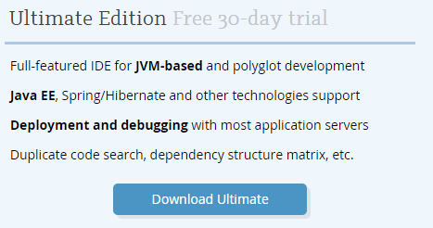

<https://www.jetbrains.com/idea/download/>

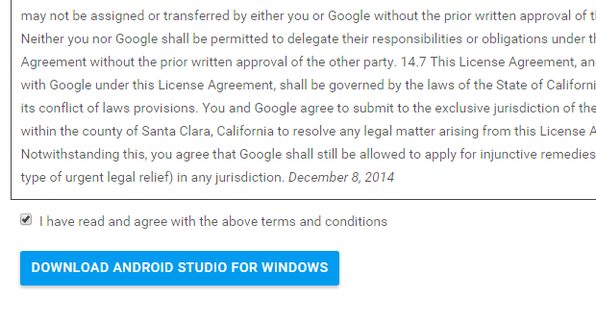<http://developer.android.com/sdk/index.html#top>

1. Open your IDE and choose to open an existing project the ToyStore Backend
2. Start your wampserver make sure that the Wamp icon turns green (or equivalent of what your server turning on is)

C:\Users\user\Desktop\Captures\greenWamp.PNG

1. Open up phpMyAdmin and create a database called toystore
   * If database already exists drop all tables in the database

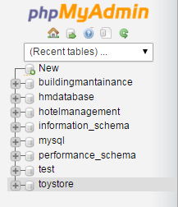

1. Once that is completed go to your ToyStore Backend and open up the application.properties file.
   * Make sure that the database you named in phpMyAdmin matches up with name at the end of the spring.datasource.url
   * Change the username and password below that to match the username and password of your phpMyAdmin server default is root with no password

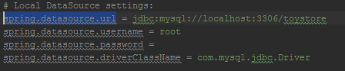

1. Open up and run each of the repository tests in the repository folder under the Tests directory
   * Once the test passes it created the tables automatically in the databse for each test that you run. To verify this open the database toystore on phpMyAdmin and the tables will be all be there.

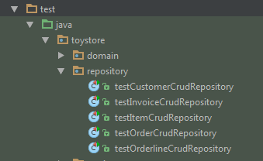

* + Once this is verified close all the files that you opened and press Alt+F12, which will bring up your terminal with the project directory automatically created.
  + In the terminal type in mvn spring-boot:run and hit enter. This should start up your ToyStore Backend on the local server.

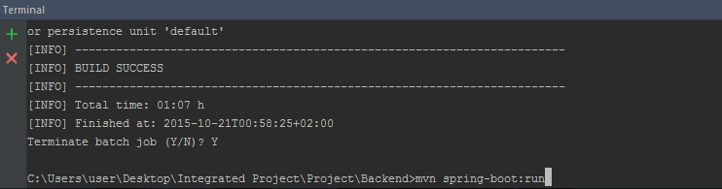

1. Now go back to the your phpMyAdmin and open up the item table in the toystore database
   * Add items to the database by following the category guide
     + 0-3
     + 4-9
     + 10-13 or Older
     + Consoles and Games
   * This is for the Select By Category option in the ToyStore Web App
   * Please see below example:

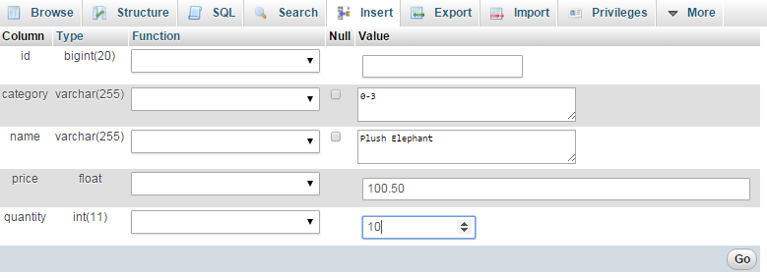

1. Once you have added as much items as you need you are free to move on and open up the ToyStore Frontend by running the home.php file.

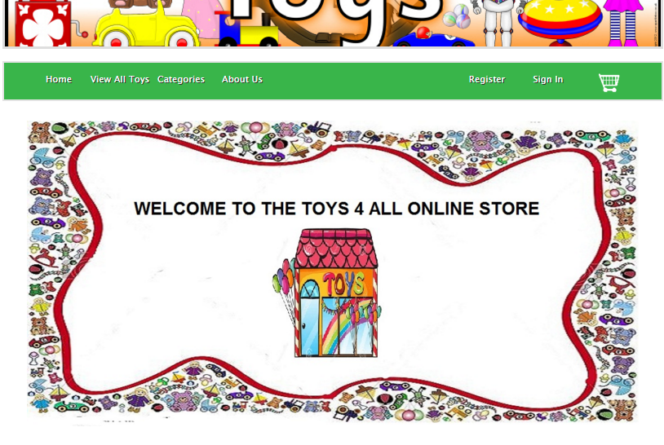

1. Above page should open if all steps were followed successfully.

The ToyStore backend was setup and developed to allow the Web Application or ToyStore Frontend Project to run and use web services. The ToyStore Backend is easily portable and pushed to application hosting cloud services such as Openshift and Pivotal who allow you run your project Backend/s on a cloud to be called anywhere the application Frontend is called.

**Project will not run if you have not successfully followed steps above.** Please contact site admin and crash handler at [jonathanerasmus1992@gmail.com](mailto:jonathanerasmus1992@gmail.com) if you are experiencing any problems.

**Known Issues:**

Problem might occur when none of the buttons are working i.e submit button post. In the case of this please ensure that your php.ini file has the following settings:

* post_max_size = 8M *Note it should not be MB but just M(Can be more but recommended between 8 and 10)
* enable_post_data_reading = on (The default is on but sometimes switching it and switching it back will sort out the problem)

**Created By:**

**Jonathan Erasmus – 211112577**

**Jarryd Pretorius – 206155247**